

Advanced search for product module

Functional Design Document

Document History

|  |  |  |  |
| --- | --- | --- | --- |
| **Version** | **Updated by** | **Date** | **Comments** |
| V1.0 | Hamzi BOUDIAF | 13/05/2015 | Creation |
| V2.0 | Sisi Wang | 22/05/2015 | Modification |
|  |  |  |  |
|  |  |  |  |
|  |  |  |  |
|  |  |  |  |
|  |  |  |  |

Document Sign-off

|  |  |  |  |
| --- | --- | --- | --- |
| **Name** | **Role** | **Date** | **Signature** |
| **Pascal ESPINOUSE** |  |  |  |
| **Florent ESTUPINA** | **Hybris developer** | **19/05/2015** | **Validation** |
|  |  |  |  |
|  |  |  |  |
|  |  |  |  |
|  |  |  |  |
|  |  |  |  |

Document references

|  |  |  |  |
| --- | --- | --- | --- |
| **Reference and Document Title** | | **Version Number** | **Date** |
|  | CGHA_Advanced search product_FDD_V1.0.docx | V1.0 | 13/05/2015 |
|  | CGHA_Advanced search product_FDD_V2.0.docx | V2.0 | 22/05/2015 |

# Table of Contents

Table of Contents 2

1 Introduction 3

1.1 Aim of this document 3

1.2 Reading the specifications 3

2 Advanced search for product module description 4

2.1 Benefits 4

2.2 Description 4

2.3 Use cases 4

2.3.1 Search for a product 4

2.4 Functional details 4

2.4.1 Search for a product 4

# Introduction

## Aim of this document

The aim of this document is to provide the Functional Requirement Specifications (FRS) corresponding to the functional description of requirements of the module advanced search for product.

## Reading the specifications

Each functionality is described as follows:

**Alert messages**

* Alert messages post fixed with (*) are given as information. They will be updated globally during the project.

**As a customer, I want to etc.**

* Story description for each functionality.

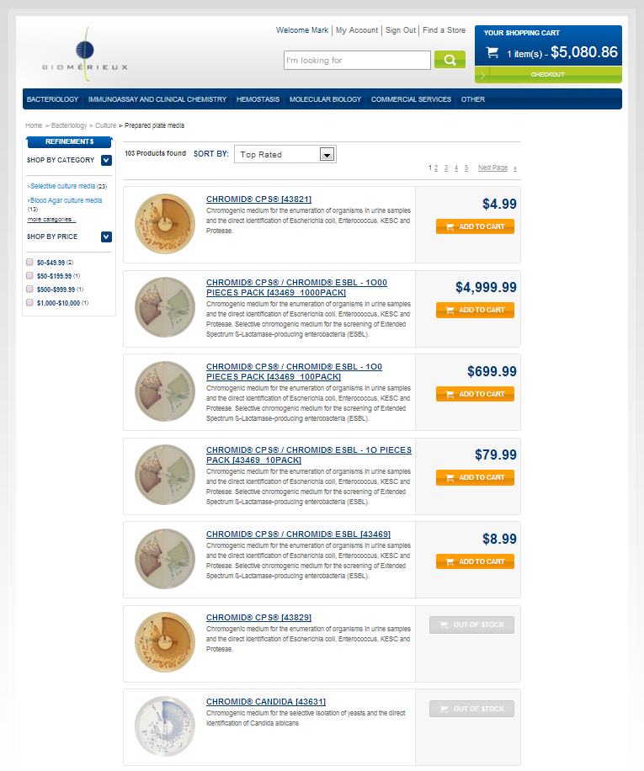

➊

➋

* The screen shot is used to illustrate the functionality.

###### Description - specific

|  |  |
| --- | --- |
| **Name** | **Description** |
|  |  |

* Detailed description for the specific development

# Advanced search for product module description

## Benefits

In a B2B site, the users are professional users and 70% of time spent on the internet is spent in the process of finding information.

As a consequence, advanced search functionalities are keys to improve customer engagement and increase the sales and order volumes.

## Description

The Advanced search for product enhanced the standard hybris search functionality.

The product search page displays all products (viewable products for the B2B unit) by using different search criteria.

The product search page is accessible via advanced search link.

## Use cases

### Search for a product

As a customer, I want to search for a product using the advanced search functionality.

## Functional details

### Search for a product

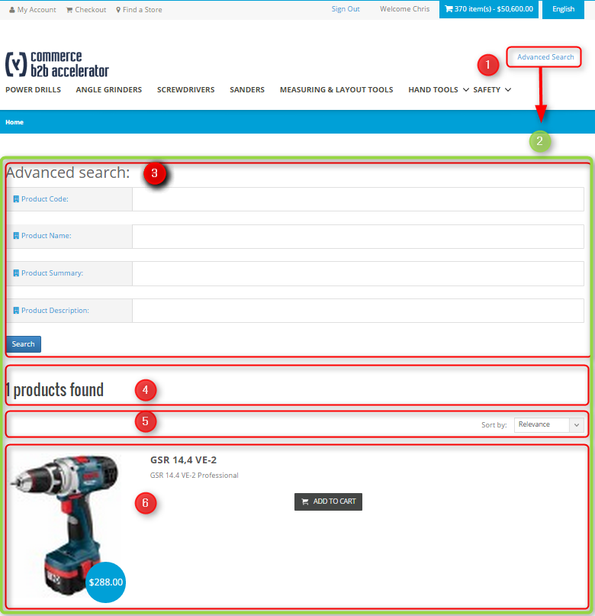

Illustration: Advanced search page

###### Description - specific

|  |  |
| --- | --- |
| **Name** | **Description** |
| **Description** | This section describes the advanced search product page. |
| **1 – Advanced search** | The advanced search for products page is accessible via a link at the top of each page. |
| **2 – Advanced search screen** | The advanced search for products is composed in 2 parts :   * Advanced search criteria (3) * Results (4),(5),(6) |
| **3 – Advanced search criteria** | For this version, auto completion is not implemented. So user needs to fill in each field with the accurate information for the search.  If several criteria are filled, the “AND” logic is applied.  The advanced search is composed of four criteria :   * Product code: it is a text field for a search on the product SKU number. * Product name: it is a text field for a search in the product name. * Product summary: it is a text field for a search in the summary of the products. * Product description: it is a text field for a search in the product description.   The search button launches the search. |
| **4 – Results number** | The number of results is displayed |
| **5 – Sort** | By default, when no search is launched, the results section shows all the products that the user is allowed to see.  The pagination displays 10 items per page.  The results can be sort by :   * Relevance (by default) * Top rated * Name (ascending) / (descending) * Price (lowest first) / (highest first) |
| **6 – Results** | For each product results, the following information is displayed :   * Photo with price * Name * Summary * Price * “Add to cart” button (a new line is created in the shopping cart) |